# 3k words maybe using some of the 10percent

# 7 – Implementation

## 7.1 Project Setup and Design - Sprint 1 (8.11.2024 – 22.11.2024)

Overview

This was the first sprint of the project, after attending the required seminar, I chose the type of software project I wanted to develop – that being a game, and selected an assistant supervisor to support the project. The choice of creating a game came easy to me as I aspire to work in the games development industry after graduating, with this project complete it would stand as a solid portfolio piece I can show to employers and display on my portfolio website (morganhodge.co.uk). This project would also strengthen my skills as a game developer, through project management , good use of version control, and 3D Unity skills.

During this first sprint I focused on outlining the initial concept, goals, and setting up my workspace. Following guidance from the seminar, I began drafting the Game Design Document(GDD), which would act as a foundational reference throughout the development process.

Sprint Tasks

* Set Up Work Environment
  + Create Github Repository
  + Set up Github Desktop
  + Create new Trello board and give access to supervisor
  + Gather all required information such as briefs and required documentation and add them to the repository
* Level Design (Paper Based)
  + Level 1
  + Level 2
* Basic Player Movement
* First Person Camera Movement (Mouse)
* First Person Walking Movement (Keyboard)
* Test Scene Created

Summary Of Actions

The player movement created for this first sprint was required as I wouldn’t be able to proceed with the development or test anything I would be implementing if I could not move around the scene.

The code implementation shown in Figure XYZ demonstrates how player movement was set up. One of the strengths of this system is its flexibility, key parameters such as movement speed, jump force, and jump cooldown are easily adjustable. This allowed for efficient playtesting and balancing throughout development, without the need to rewrite core logic.

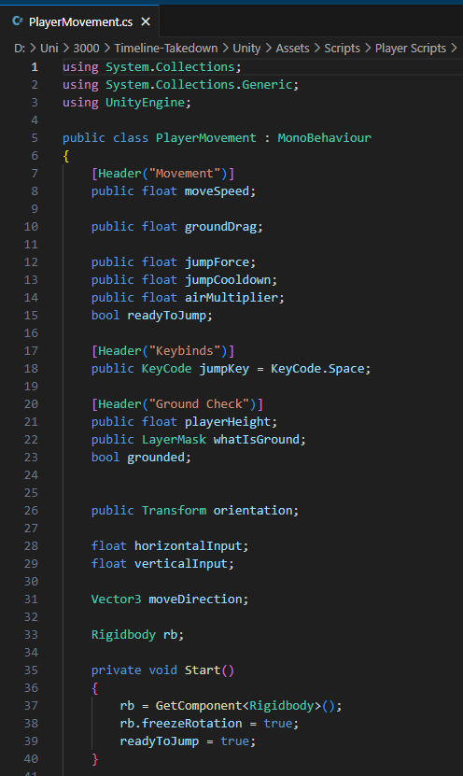 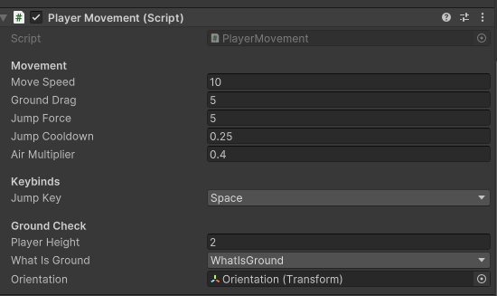

Figure XYZ FIGURE XYZ

Additionally, the paper-based level designs were created in this sprint but were not displayed until the Devlog 1.

## 7.2 Research and Game states - Sprint 2 (22.11.2024 – 6.12.2024)

Overview

This second sprint mostly consisted of setting up game states such as a Start Screen, Pause menu and settings tab.

Research was also conducted in this sprint, exploring art styles I could use as well as potential assets for the enemy type – this was documented within the Devlog 1.

During my research into art styles and visual design within video games, I was recommended several books that would be relevant to game development. As a fan of the franchise they are based on, I was eager to purchase these books and learn from them. The books I purchased during this sprint and studied included:

* The Art of Fallout 4 – A detailed look at the environment and character design choices made in fallout 4 , this was useful reference material for post-apocalyptic and sci-fi aesthetics.
* Elden Ring Art Book Vol1 – This book offered insight to the world building , creature design and atmospheric art direction that was used in Elden Ring, this helped me understand how to setup an atmosphere in a level using certain colours and audio.
* Blood Sweat and Pixels by Jason Schreier – This is not an art book but was highly recommended within the game’s development community. This was an insightful read as it provided a look on how games are really constructed and the struggles and triumphs of game development across multiple different studios. This was a strong motivational resource during my own development.

Sprint Tasks

* Devlog 1 created – <https://www.youtube.com/watch?v=Su4Demj-MFw>
* Paper Based Concept Art
* Created basic UI on Inkscape
* Game states created Menu-Start-Pause
* Movement tweaking

Summary Of Actions

Concept art was sketched up, this was the result:

*Figure X, Concept Art*

The UI elements were initially created using Inkscape. I approached this stage knowing that these assets would just act as placeholder visuals, rather than the final design. The goal at this stage was to have functional UI in place for testing gameplay mechanics and user interactions. An example of this early placeholder Art can be found below in figure XYZ.

*Figure X , Basic UI created in inkscape*

When researching into how to create the different game states (such as main menu, pause, game over) I thought I would have to create separate Unity scene for each state and manage them using scene indexes in the build settings. However, through further research and advice from online resources, I learnt that using separate canvas objects with a single scene was a much more efficient approach. This method allowed for better performance, 0 loading time, easier UI management and smoother transitions between game states.

## 7.3 Assets and Online Resources - Sprint 3

Overview

This sprint primarily focused on researching suitable online assets and exploring AI tools to generate temporary placeholder art. I aimed to find assets that matched the intended visual style and tone of the game while also making sure they were suitable for implementation into Unity.

During this stage, I created a test scene where I imported and arranged some of the selected assets as this allowed me to visually evaluate how well they fit and the overall aesthetic.

Sprint Tasks

* Devlog 2 created – https://www.youtube.com/watch?v=RXlF7QE14os
* Created Document of assets
* Created a test level and imported certain assets
* Used tools to generate UI and Loading Screens
* Started to create a block out level for game mechanics to be tested

Summary Of Actions

When creating the document of assets I would be potentially using, I focused on finding free, copy safe assets that could be used within the game. To keep track of the resources I found I created a word document compiling the names and download links of each asset. A copy of this assets list can be found in Appendix X.

During a recent supervisor meeting I was recommended an AI tool called DeepAI, which is capable of generating images for free. Following this advice, I used DeepAI to produce placeholder art assets for the game. Since developing fine visuals was not a top priority at this stage, using AI generated assets allowed me to maintain visual consistency while focusing on gameplay functionality.

Lastly, I downloaded a selection of the most appropriate models from the asset list I had compiled. These assets were then imported into a test scene in Unity, allowing me to evaluate their visual compatibility with the games intended style and theme. This hands-on assessment provided immediate visual feedback, helping me decide whether each asset was suitable for continued use or needed to be replaced or modified.

*Figure xyz : A screenshot from my devlog showin the models imported*

## 7.4 Enemy & Main Game Loop - Sprint 4

Overview

At this stage of development I was working on the games functionality you could now end the game by picking up “end game” part. Enemies are now implemented, they have the ability to locate and follow the player, and adjustable parameters like speed. Additionally, the player now has a health system, allowing them to take damage, die, and regenerate health.

Sprint Tasks

* Devlog 3 – https://www.youtube.com/watch?v=vxEHmGPZ-y4
* Health Functionality
* Enemy Controller
* Level can be completed
* UI
* Map Design on Dungeon Scrawl

Summary Of Actions

To enable enemy pathfinding and movement I had to first bake a NavMesh onto the ground surface within the scene. This allowed the enemies to navigate the environment using Unity built in NavMesh system.

I then create a script that uses Unity’s NavMeshAgent component to control the enemy’s movement. The script constantly updates the enemy’s destination to follow the player’s position. To avoid potential runtime errors, I added a check that checks to see if the enemy is still alive, that the NavMeshAgent is still active, and that it remains on a valid section of the NavMesh before attempting to move.

Figure XYZ: Enemy Controller

During this sprint, the players health system was implemented, allowing the player to take damage and heal. If the players health bar reaches zero, the game ends. However, enemies are not yet capable of dealing damage. To test this functionality of the health system, I created a test object that when interacted with would damage and heal the player. This was used as a temporary method to test the health mechanics until enemy interactions could be fully integrated.

Lastly, I transferred the paper-based level designs to digital format using a tool called Dungeon Scrawl, this was recommended by my supervisor. This was beneficial as it provided a clearer visual representation of the levels, and this was crucial when trying to translate designs into Unity.

Figure XYZ: TOP PAPER BTM DIGITAL

## 7.5 Minimum Viable Product - Sprint 5

Overview

At this stage, the game had reached its Minimum Viable Product (MVP) phase, meaning it had the core functionality required to be considered a working project. The main game loop was fully implemented, including the wave manager, which handles enemy spawning and progression. Projectile mechanics were set up, allowing the player to attack enemies. Enemies were now able to both take and deal damage and were set to despawn upon death as animations had not been implemented yet. Additionally, the wave system was functioning correctly, with new waves only starting after the appropriate number of enemies had been defeated in the current round.

Sprint Tasks

* Early Stage of Wave manager
* Projectiles
* Enemy Spawn Points
* Enemies can take damage
* Start of Power Up implementation

Summary Of Actions

The wave manager script is a central part of the games round based survival system, it controls the flow of enemy waves, tracking the progress of the round through the use of Unity Text Mesh Pro UI, and manages the boss spawning.

The script begins by checking the current wave number and uses a predefined array called enemiesPerWave to determine how many enemies should be spawned for each wave. If the wave is marked as a boss wave, a boss enemy is also spawned. To prevent duplicate spawns, a bossSpawned flag ensures the boss is only spawned once per wave.

Each time an enemy is defeated, the method EnemyDefeated() is called which increments the kill count, but this may be removed by the final release as this is mostly used as a debugging tool and not a final game feature. Also, the number of enemies remaining in the current wave is decreased and the UI is updated to reflect this.

*Figure XYZ Enemy Defeated Method*

When all enemies in a wave are defeated, the game waits a few seconds using WaitForNextWave() before transitioning to the next wave using the StartNewWave() func. Once the final wave is complete, the script plays a victory audio que and stops any more waves being spawned.

*Figure XYZ*

The enemy spawner is responsible for spawning enemies and bosses during gameplay, based on wave progression that is integrated within the wave manager. It allows me to set spawn points and enemy prefabs through the Unity inspector, allowing me to have full control and flexibility over how and where the enemies appear.

When a new wave starts the StartWave() method is called, which begins a coroutine SpawnWave() that instantiates a set number of enemies at randomised spawn points. A delay between spawns is needed or multiple enemies can spawn at the same spawn point , causing issues such as overlapping or leading to the enemies damaging each other.

*Figute XTZ*

Whenever an enemy is defeated, EnemyDefeated() is called, which passes that information back to the wave manager to update the wave progression and necessary UI elements.

Projectiles

## 7.6 Animation and Aesthetics - Sprint 6

Overview

This sprint was dedicated mostly to the visual elements of level 1, as of last sprint I had completed the base game loop, now it was time to start making the game look aesthetically pleasing. Towards the end of the second week of the sprint a private play test was conducted, this was mostly for feedback on the new visuals.

Sprint Tasks

* Devlog 4 - https://www.youtube.com/watch?v=lJwd-J0-sTs
* Enemy Animations
* Working on Level 1 Aesthetics/map layout
* Ambience sound script
* PowerUps

Summary Of Actions

#### Animation implementation

At this stage the enemies had no walking or death animation, this caused them to appear as if they were hovering towards the player rather than moving realistically. As I had no prior experience with Unity’s Animator tool, this challenge proved to be a big learning curve for me. However, after watching several online tutorials and receiving guidance from lecturer Tyler Cheng, I was able to successfully integrate animations into the enemy model. This greatly improved the games visual flow and made enemy movement feel more natural and immersive.

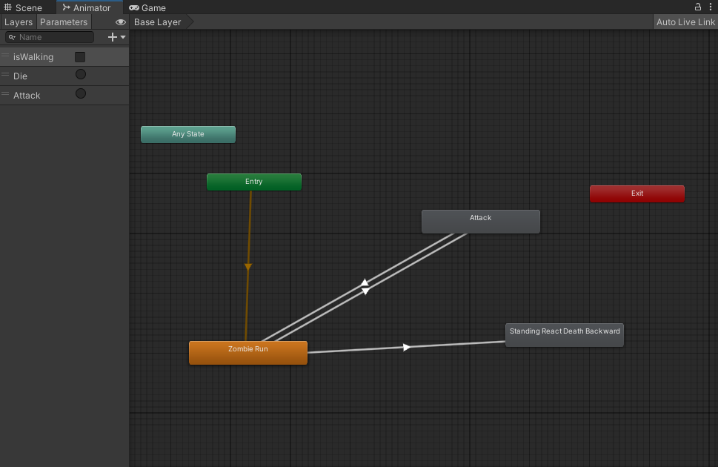

*IMAGE OF ANIMATOR*

#### Ambience sound

When conducting research for this project, I learned that a lot of games in this category utilise ambience sound. What this means is that when the player moves to different locations the audio changes seamlessly with them, it can add a more immersive feel to the game.

As a developer who is creating a game within the same category, I wanted to introduce this mechanic into my game. I did this by researching online into how you can create ambience sound in your game as I knew it was more advanced than simply adding an audio source into the game scene.

What I had to do was create a script that continuously updates the position of an ambient sound source based on the players location. Specifically, the script calculates the closest point on a defined collider area to the players position using Collider.ClosestPoint(). This value is then used to reposition the sound emitting GameObject to that point in every frame. This makes the audio appear to be coming from the environment rather than following the player directly. I could add multiple box colliders on the scene, each acting as there own sound area, allowing for smooth audio transitions when going to different locations such as inside the pyramid has an eerier audio compared to the Egyptian music outside.

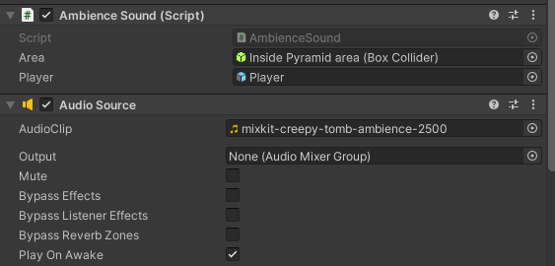

Figurer

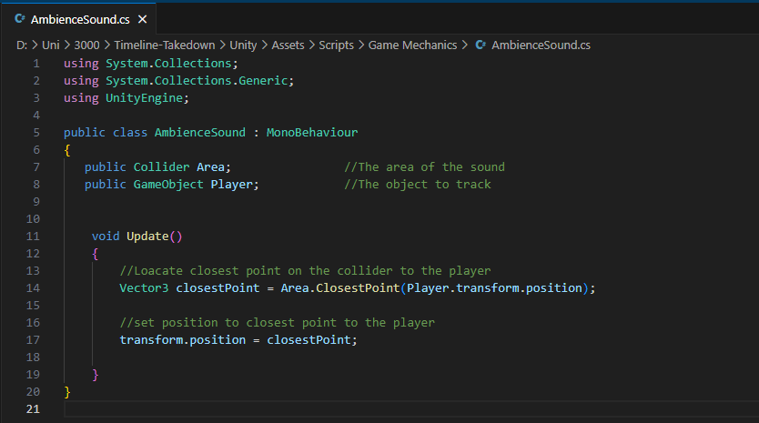

Figure

## 7.7 Poster & Level 2 - Sprint 7

Overview

This sprint primarily focused on creating the poster for the game, I wanted to create something that I can use online to promote the game so I spent a lot of time on it. Also during this sprint I worked on polishing parts of level 1 such as creating different weapons, as well as bullets. Level 2 was also planned.

Sprint Tasks

* Poster
* Level 2 Design
* Gamestates
* Polishing of Level 1

Summary Of Actions

#### Poster

All versions of the poster can be found in appendix xtyz

#### Changes for level 2

Level 2 was originally planned to be an underwater shipwreck environment featuring swimming mechanics. However, during this sprint I came to the realisation that this was not a feasible idea as I had a limited timeframe. After conducting extensive research into swimming mechanics and the complexity involved in it, I decided that it was best I shifted the direction for level 2.

As a result of this I decided upon a new concept, an abandoned World War 2 hospital overrun by dead soldiers. This setting still preserved the eerie tone I was aiming for, while still allowing me to reuse existing movement and mechanics without the need for complex underwater systems. A level layout was created using Dungeon scrawl to help plan for the upcoming sprint.

*Figure xyz*

## 7.8- Zombie Behaviour & Public Playtest - Sprint 8

Overview

This sprint marked the start of the development of Level 2. With the level design already created in the previous sprint, I began blocking out the environment within a separate scene in Unity. This sprint also featured the first public playtest, which extended beyond the designated private testing with selected individuals. Finally, work began on implementing enemy attack behaviour.

Sprint Tasks

* Devlog 5 - https://youtu.be/2hVWVUD5KXo
* Level 2 Blockout
* Level 2 Enemy Animations (running)
* Level 2 Zombie Attack Script
* Public Playtest

Summary Of Actions

#### Level 2 Enemy Attack

When designing the enemy behaviour for this level, I decided that a close-range melee attack would be more fitting than projectiles, given the zombie themed enemies and the confined indoor environment. The enemies were intended to swipe or bite the player when within range, aligning with traditional zombie behaviour in games. Although the attack animations had not yet been implemented at this stage, the foundational attack script was developed, attached to the enemy models and fully working.

*Figure XYZ*

This script allows the enemy to deal melee damage to the player when they are within range. It uses a trigger collider to detect when the player is close and checks a timer to ensure the enemy only attacks at set intervals.

#### Public Playtest

The first public playtest was conducted during this sprint, prior to this all playtests had been undertaken within an organised environment I created, with play testers that I handpicked.

If you wish to read more about this public playtest than I speak about this more in REFRENCE TO HERE. But the overall outcome of this was that I needed to make the game harder and there were a few minor visual bugs. I swiftly made changes to the game upon this feedback, and I would say that the playtest was successful.

*Figure XYZ: Undergoing a playest*

## 7.9- Sprint 9

Overview

This sprint was mostly spent building level 2, I began by sourcing appropriate assets online that complied with LSEP guidelines, checking they could be freely used in my project. With those assets gathered I transformed the level from a basic blockout into a fully fleshed out abandoned hospital. For this I used ProBuilder within Unity as I encountered issues with RealtimeCSG in the previous level and found ProBuilder to be more reliable.

Sprint Tasks

* Devlog 6 - https://youtu.be/nWcjUrmOtSQ
* Building Level 2
* Enemy Attack animations
* L2 Boss
* Level 2 Baking NavMesh and making sure the wave manager and other scripts work
* Started Itchio page
* Found assets

Summary Of Actions

#### Level 2

This sprint was primarily focused on completing Level 2 to ensure I had a Minimum Awesome Product (MAP) by the end of the sprint. The entire level, consisting of multiple rooms, was created using various asset packs and audio sources, which are detailed in the appendix under the asset list.

During this sprint attack animations were added to the enemies that were only triggered during attacks. Additionally, a boss was introduced which spawns in during round 5 and drops the timepiece part once being defeated.

Once the level design was complete the NavMesh was baked onto the ground, and all necessary game scripts were integrated onto the scene to ensure the game loop functioned as intended.

#### Itch

As the project was nearing completion, I created an itch.io page to showcase the game. This page was a platform to share progress and attract players to save my game so that when it releases in the future, they will be notified instantly.

Content was starting to be created for the page, including artwork, screenshots, and a description.

*Figure XYZ : early version of ittch page*

## 7.10- Minimum Awesome Product - Sprint 10None of this is perfect

Overview

Now approaching the end of this project, I plan to spend the remaining time working on polishing as the game loop is now completed and all functionality is now implemented. The powerups were the last required functionality needed and they were added this sprint.

Time was also spent polishing up the story telling of the game, and the gamestates (menu, level, game over etc)

Sprint Tasks

* Devlog 7 - https://youtu.be/-r5FLIDuMCo
* Polishing everything (floors , walls, textures)
* PowerUps fully implemented
* New UI created
* Testing
* Voice overs for story telling

Summary Of Actions

#### Story Telling

During this final sprint I realised that there was not much lore/ storytelling within this game. In the GDD I wrote how I wanted to have voice acting and storytelling within the game. So during this sprint I added a voice over at the main menu that informed the player the background to the game, and then at the end a voice over that concludes the story.

This was simple to implement …

#### Powerups

Multiple powerups had been added, this included max health, double speed, and invincibility. Alongside this a visual display was implemented through the use of canvases and images that would display a image once a power up had been picked up and would last for as long as the powerup had been set for.

Figure XYZ

## 7.11 Uploading the Game – Post Project – Sprint 11

Report

Video

Testing

Itch

Future plans but I will discuss that later